JAVASCRIPT PART 2

* **HOW java script works:**

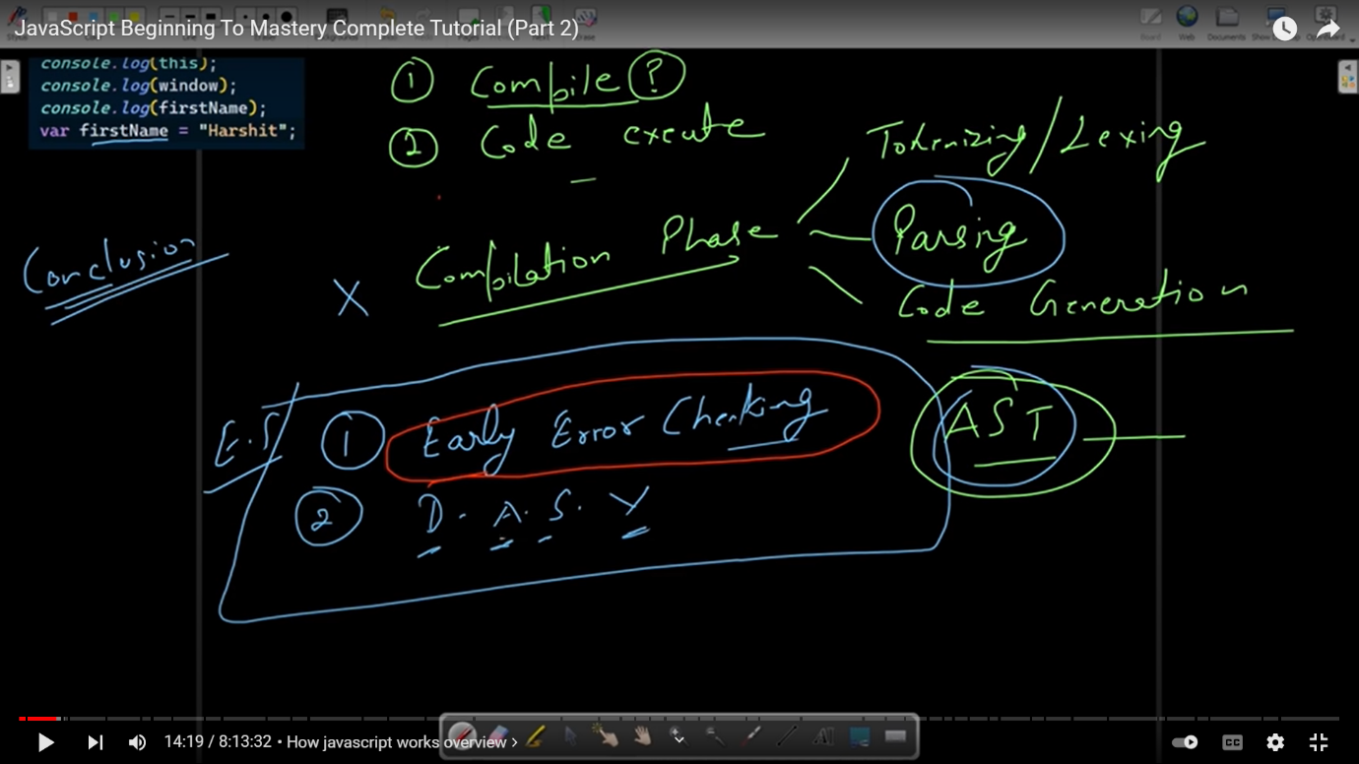

D. A. S. V: determining appropriate scope for variable(GLOBAL SCOPE OR ANY OTHER SCOPE )

Tokenizing / lexing

SYNCRONOUS PROGRAMMING LANG : those programming lang which excute order by order (phele first line ka code exucte hoga then next line ka code excute hoga )

Eg : java script is synchronous programming lang hai .

2. CODE EXCUCTION :

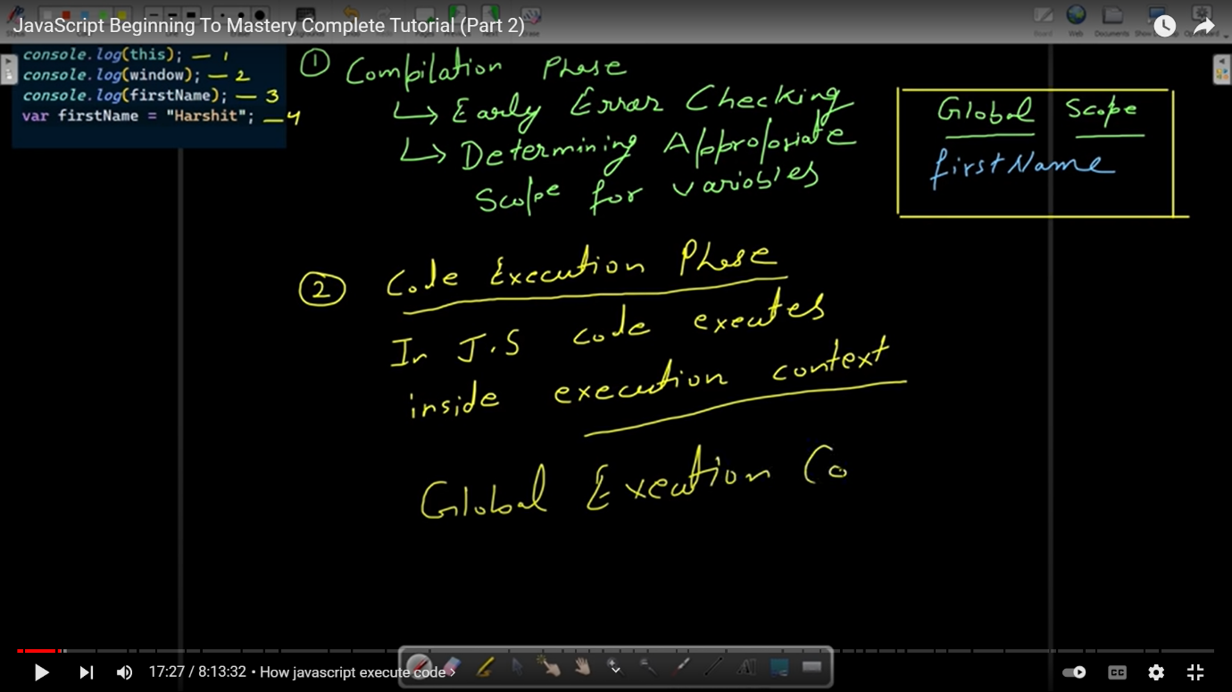

Eg of code execution :

1 .

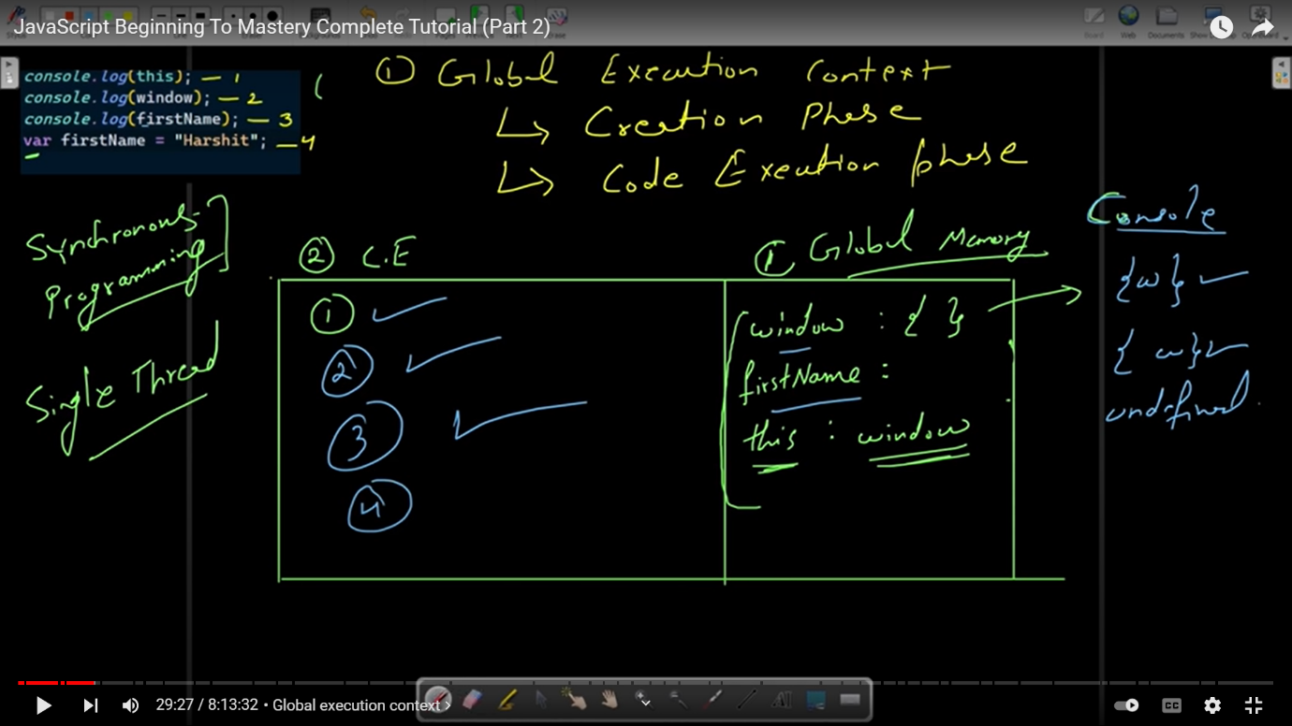

2.

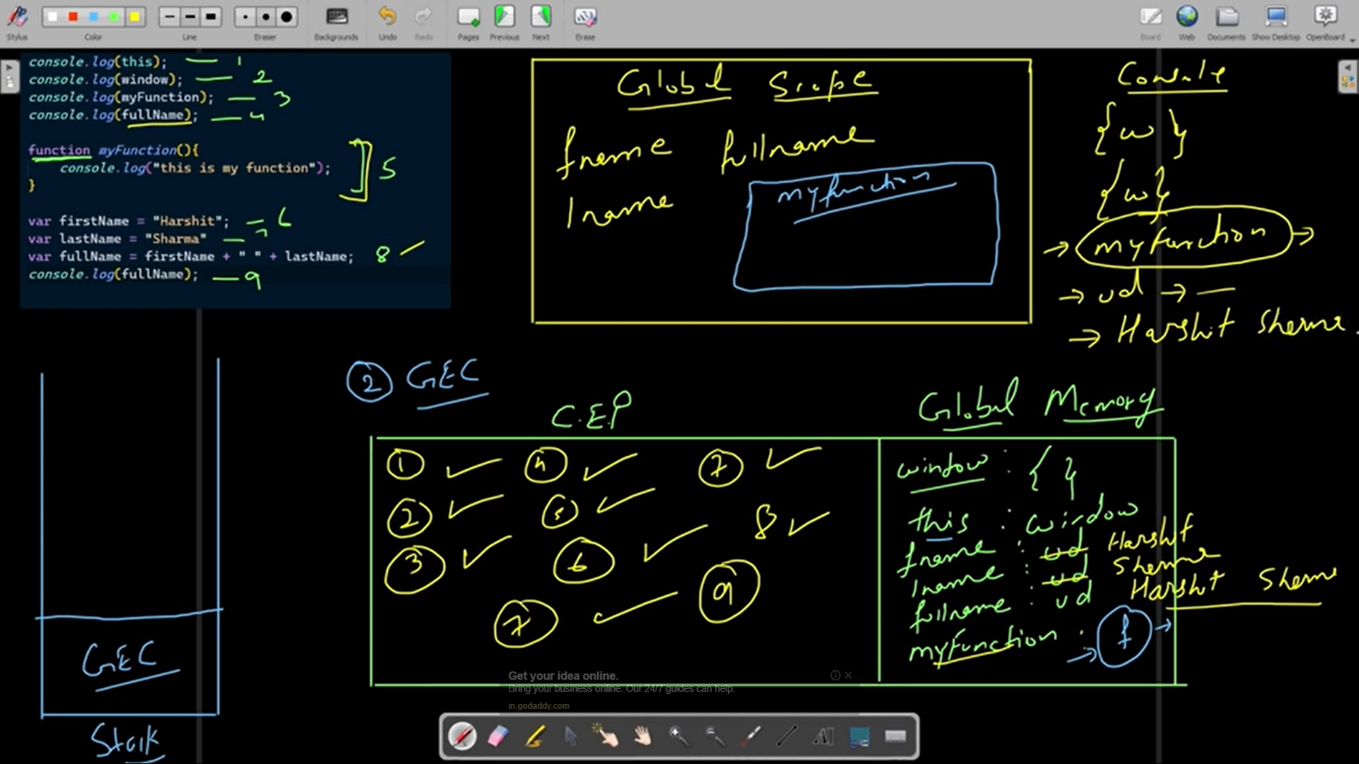

CODE EXCUTION IN FUCTION EXPRESSION AND FUCTION DECLERATION :

1 . function expression



2. function declaration:

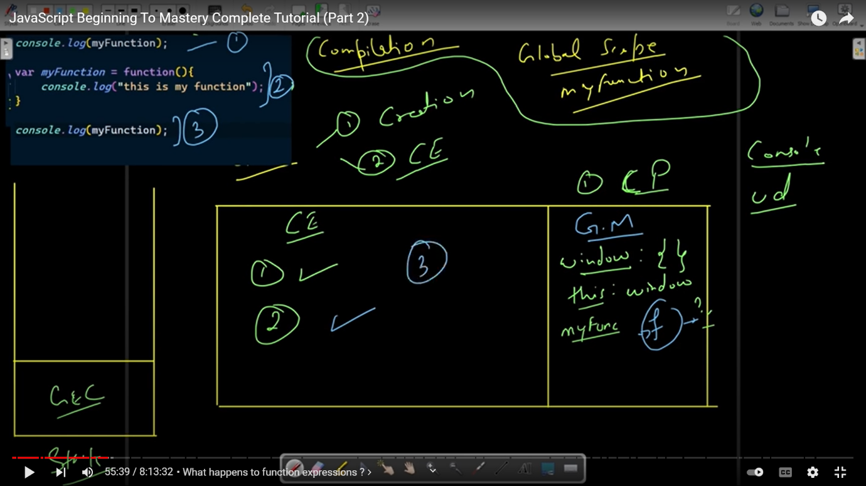

* DURING Golobal execution context -> in creation phase (global memory )
* 1 . var se define variable : undefined
* 2. Let or const se define variable : uninitialized

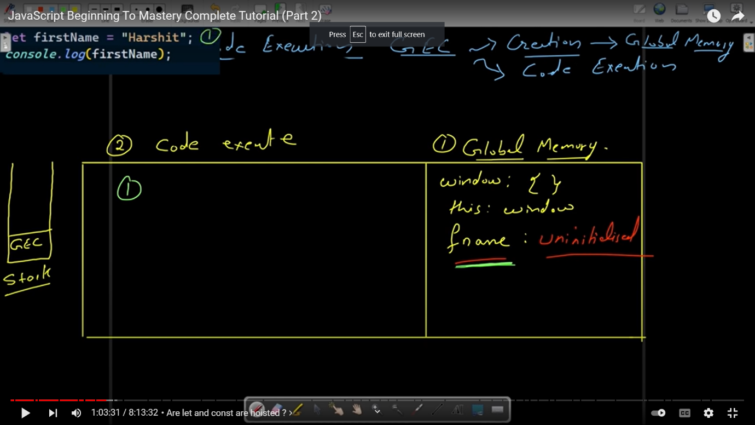

Note : let and const ki bhi hosting hoti hai .

*** TDZ : Tempol dead zone

* **Function execution context :**

**When ever we are calling function then function execution context will going to called separately**

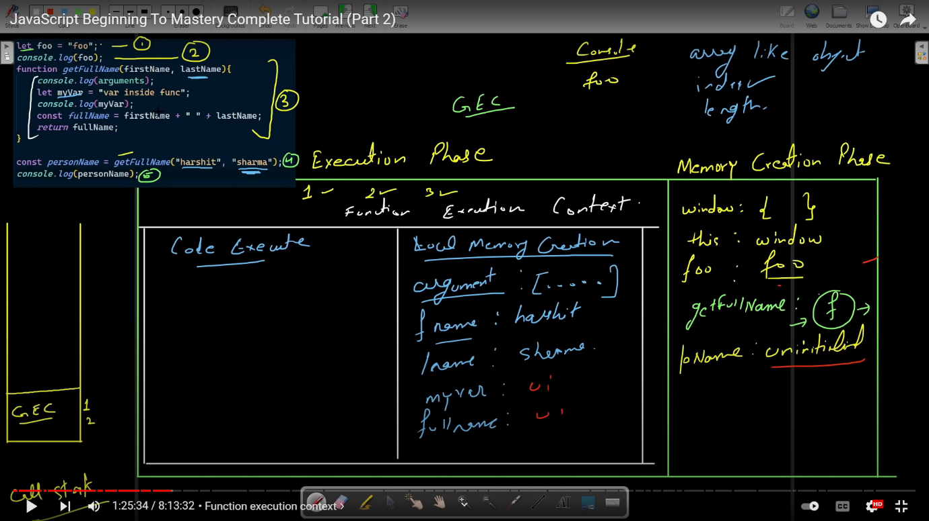

Argument : array like object (note : all argument of function )

* Lectical scope : agar koi calling thing local memory me na mile to hum usko uska parent scope or memory mai search karenge . yeh hum jab tak karenge tab tak golabal scope (golabal memory mai na kohj le )

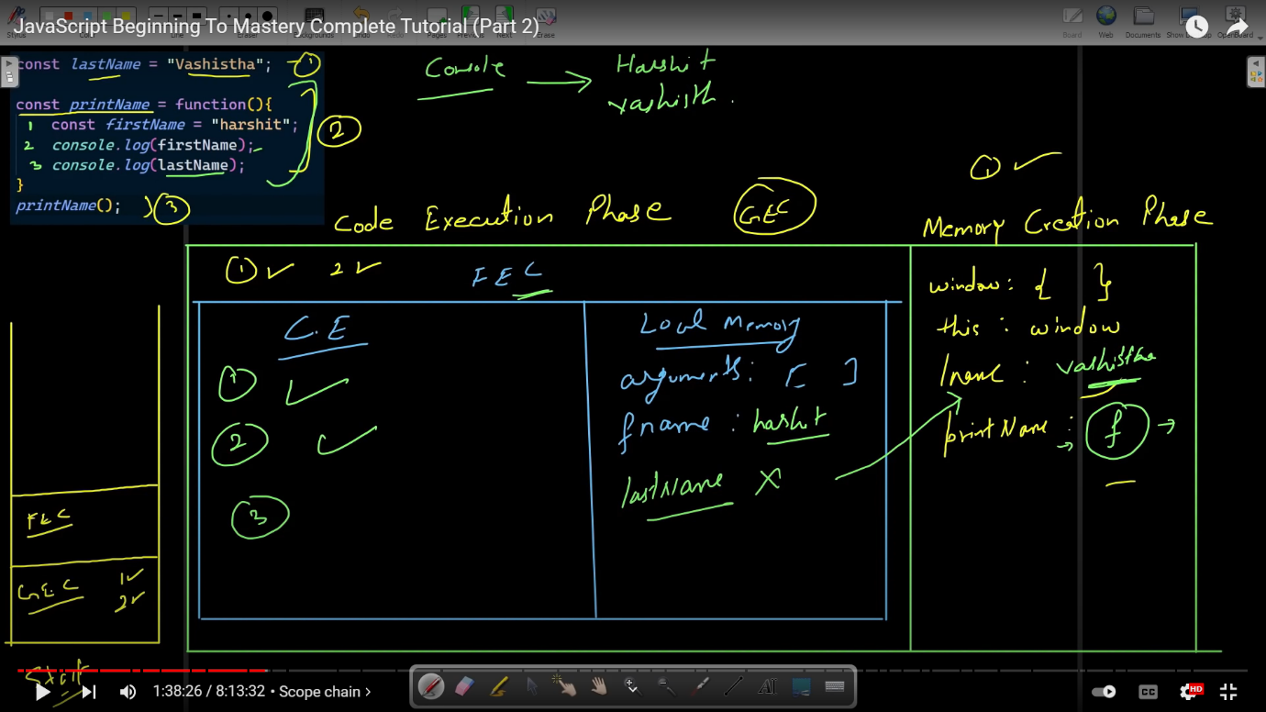

CLOGERS :

Function returning function

Agar function returning function then wo apne argument ko local memory se leleta hai not like lectical scope

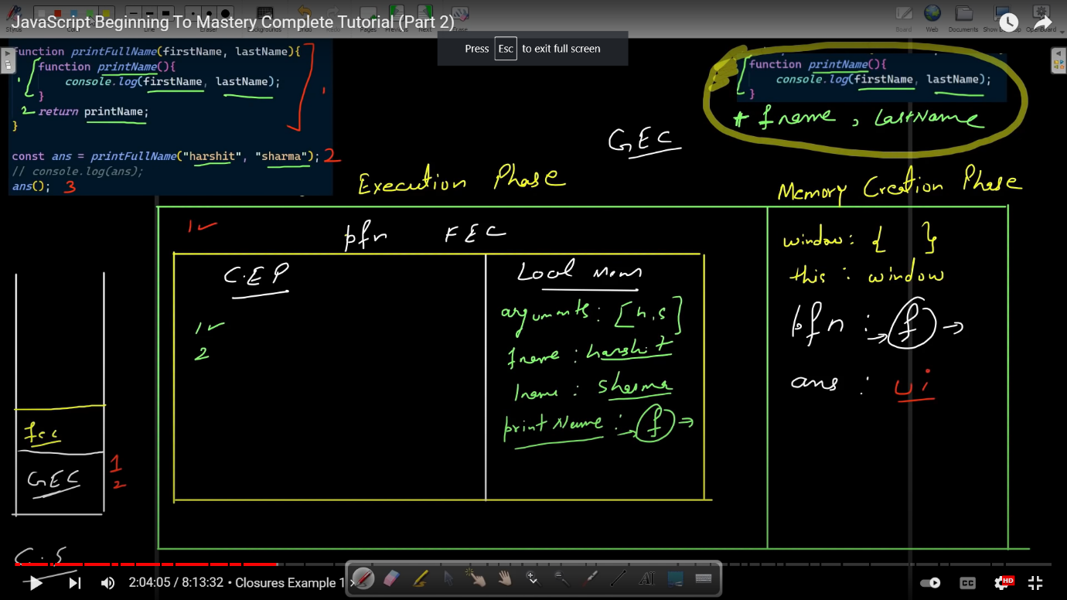

Eg :

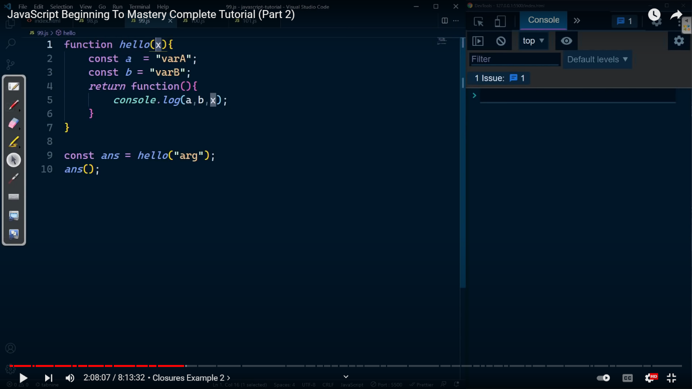

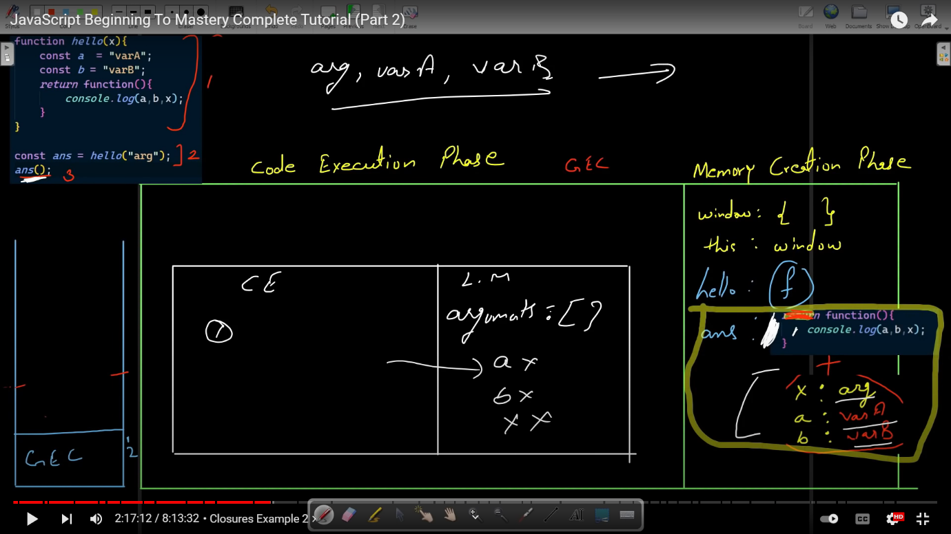

Eg :

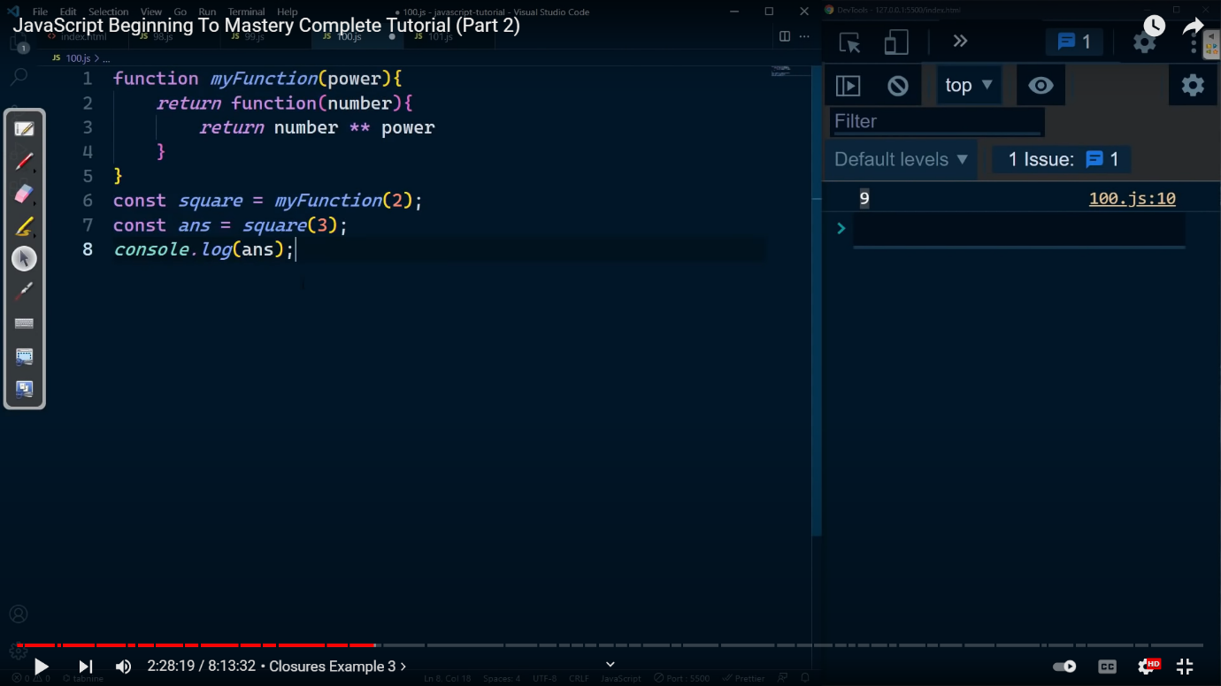

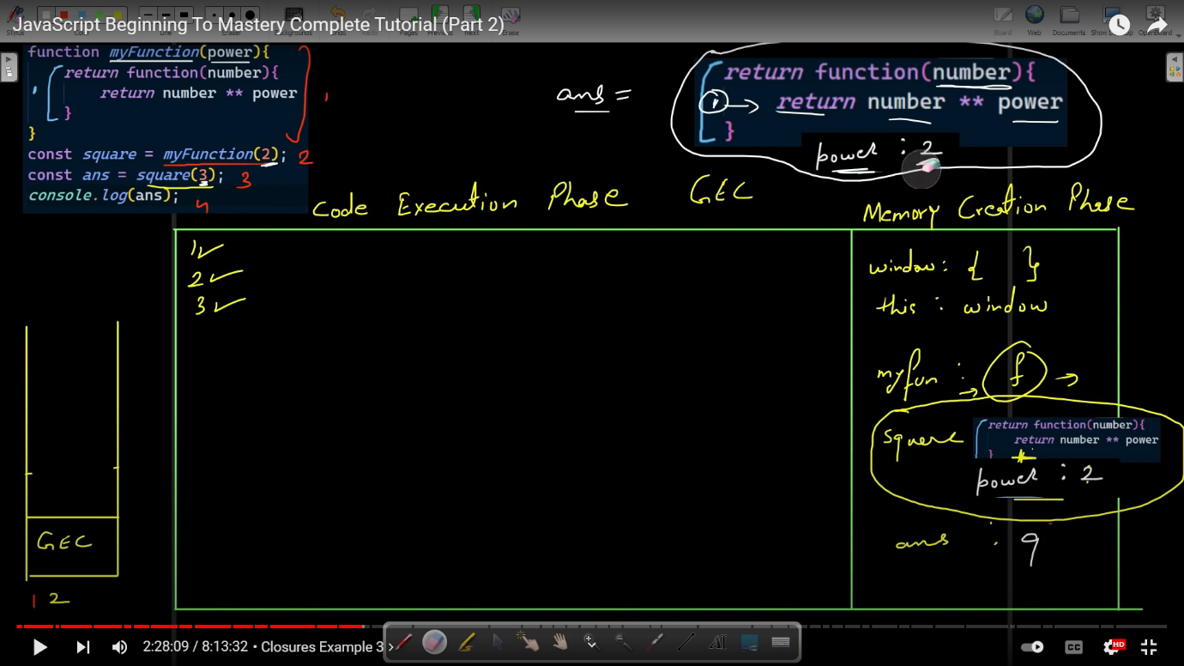

Application of closer :

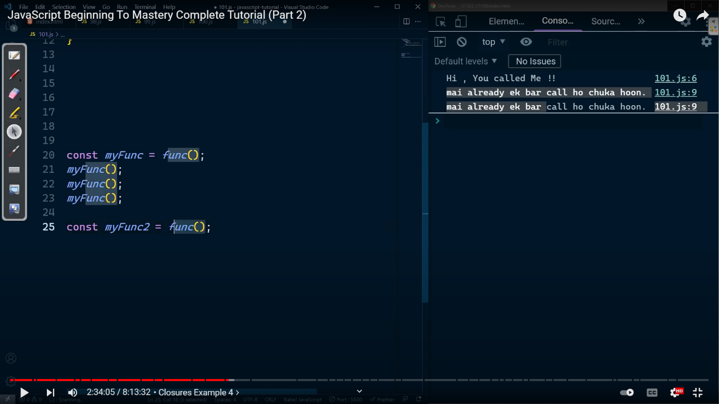

*function* fun(){

    temp=0;

    return *function*(){

        if(temp<1){

            console.log("Hi you called me");

            temp++;

        }

        else{

            console.log("hi you again called me !");

        }

    }

}

*const* myfun=fun();

myfun();

myfun();

myfun();

myfun();

*const* myfun2=fun();

myfun2();

myfun2();

myfun2();

myfun2();

myfun2();

Different way of adding java script in our website:

Java script file first load then execute

1 .Adding js in head :

<script src=”pr.js”></script>

Disadvantages of using this is :

1. it will going to load but it will not going to excute and give error .

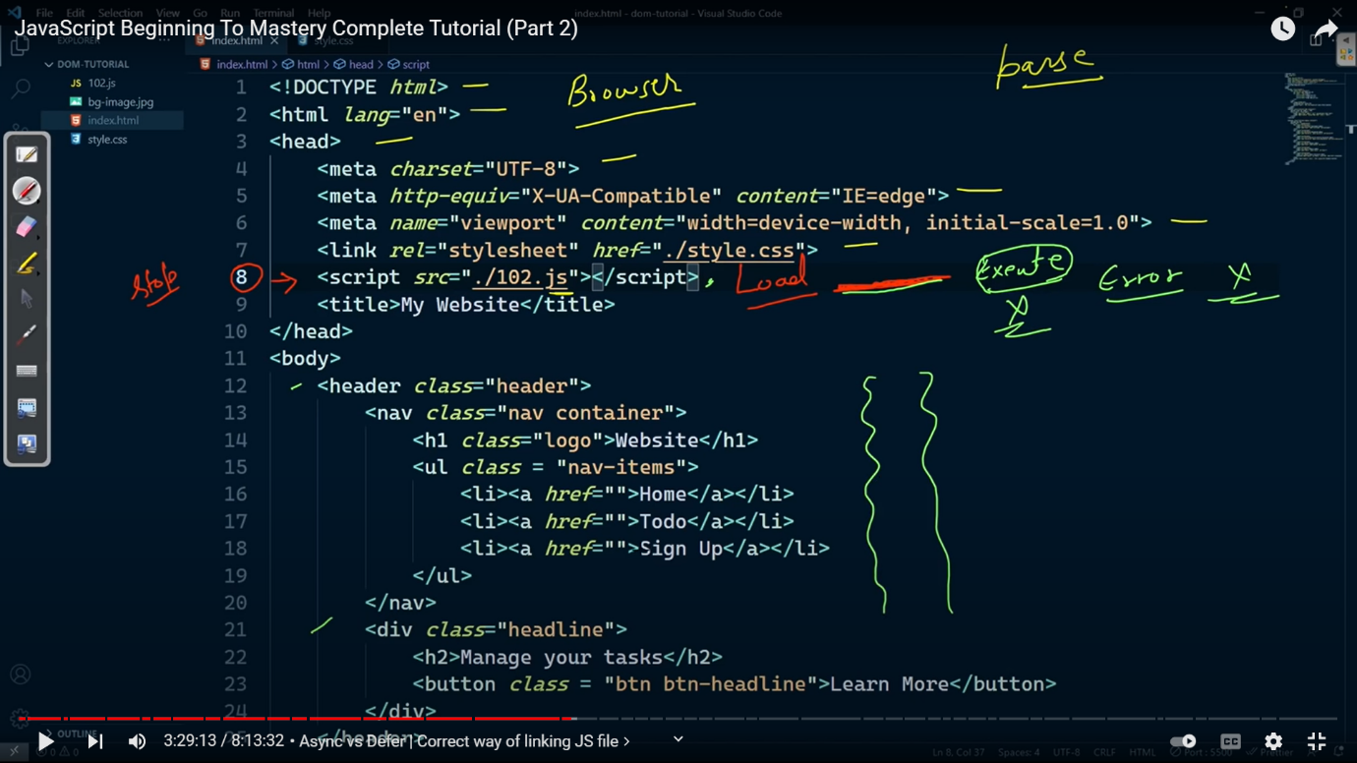

Note we do not use this method:

2 . Adding js in at the end of body :

It will work . firstly it will going to load and execute but it will take some time because it will going to take some time to load first html file then it will going to load css file then it will load js file .

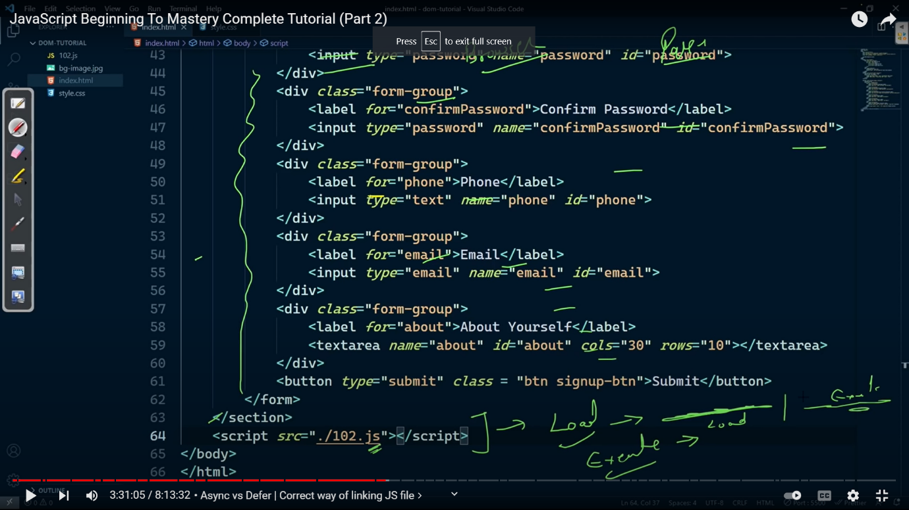

3 . adding js in head with asyn :

It will going to parse and load simultaneously

Both js and parsing occur symomentously -> once js loading is completed then parsing will going to stop -> js fiel will going to excute

Drewbacks : incomplete parsing

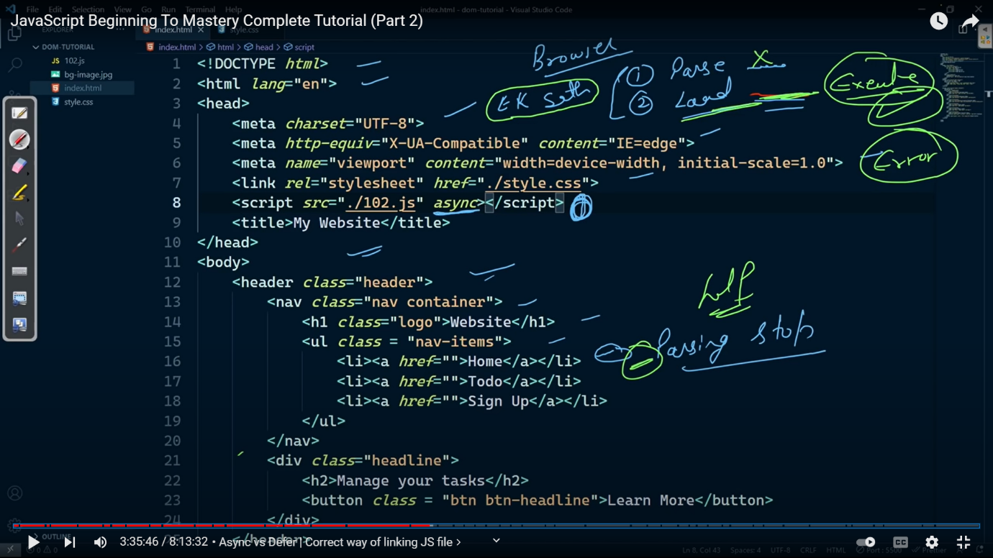

4 . body with deffer : best way

Here loading and parsing occur simultaneously . once loading of js file is completed parsing will not going to stop to execute the js file . once parsing of completed then js file will going to execute .

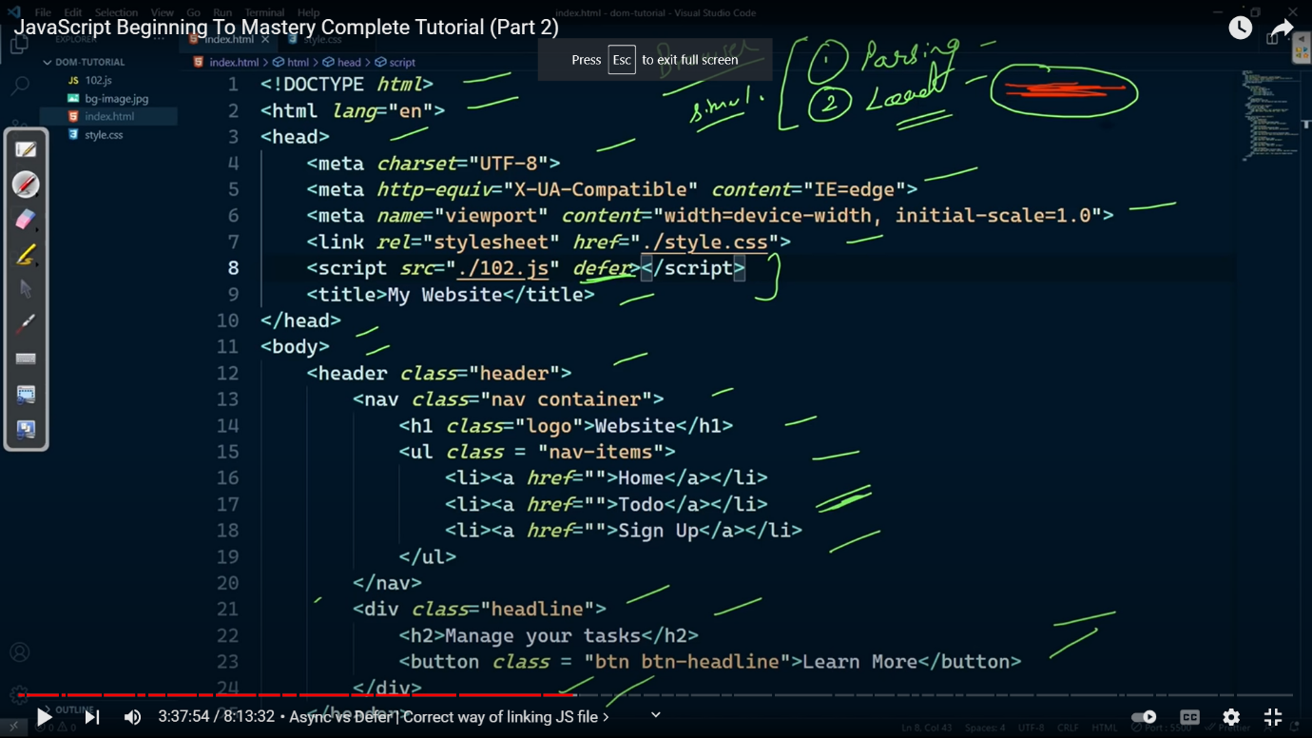

Diffrece between asyn and differ :

Asyn : parsing and js file loading occur simultaneously . once the loading of js file is complete then parsing stop to excute the js file .

Differ : here parsing and js file loading occur simultaneously . once the loading of js file is complte then parsing will not going to stop . once the parsing completed then js file will going to execute .

Slecting element in java script from the html file :

1 . document.getElementById()

*const* main_heading=document.getElementById("heading");

1.document.getelementbyclassname() // it will going to give array like object of all the class with same name

🡪to slect any one of them can be done by indexing selctor

2.document.qurySlector(“#id”) or (“.class”) // note it will going to give the element which first define with the class .

*const* main_heading1=document.querySelector("#heading");

*const* main_heading1=document.querySelector(".class");

3 . document.qurySlectorAll(“.class”) // through this will going to access all the element with the class .

*const* container=document.querySelectorAll(".container");

console.log(container);

4 specfic slector :

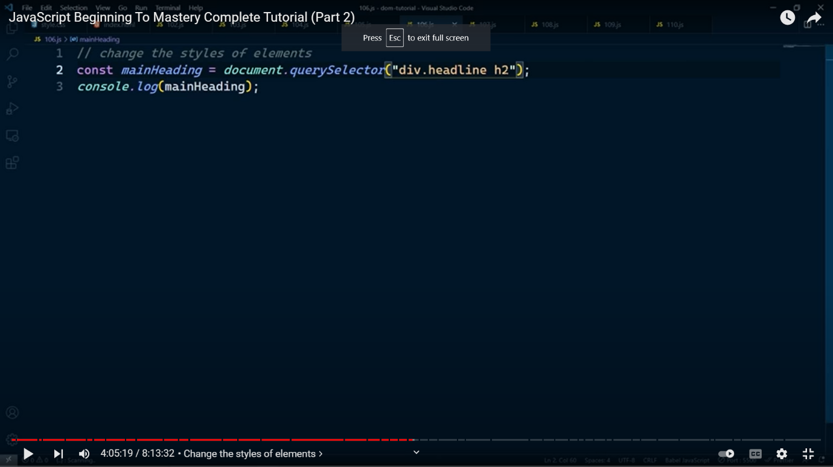

5 . attributes slecor

getter and setter :

1. .getattributes()
2. *const* link=document.querySelector(".header a");
3. console.log(link.getAttribute("href"))

2. .setattributes()

*const* link=document.querySelector(".header a");

console.log(link.getAttribute("href"));

link.setAttribute("href","#home");

console.log(link.getAttribute("href").slice(1));

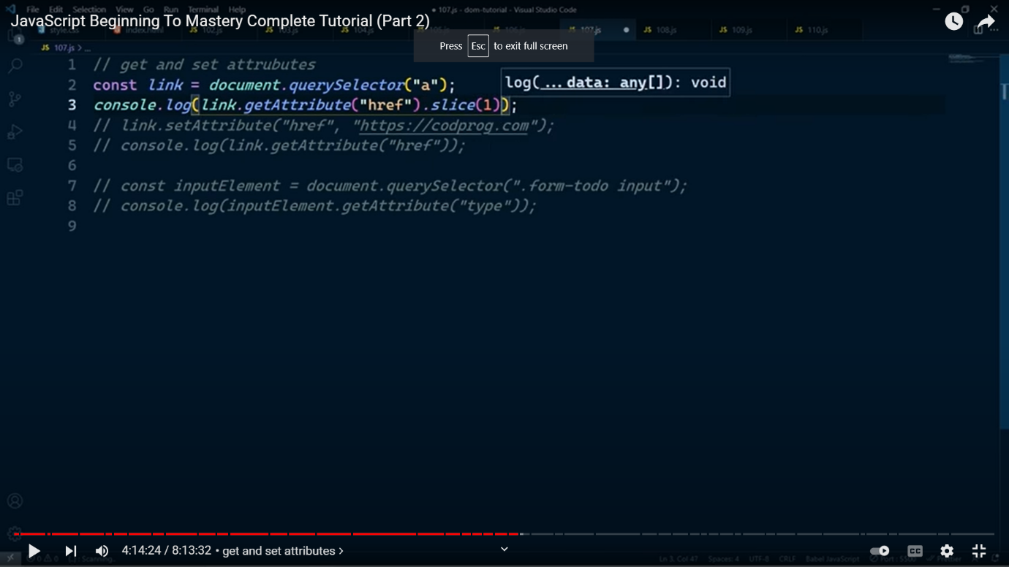

6 .Multiple slector

a. document.getclassbyname();

b. document.quryslecorAll(“.class”) ;

Application of java script in html file .

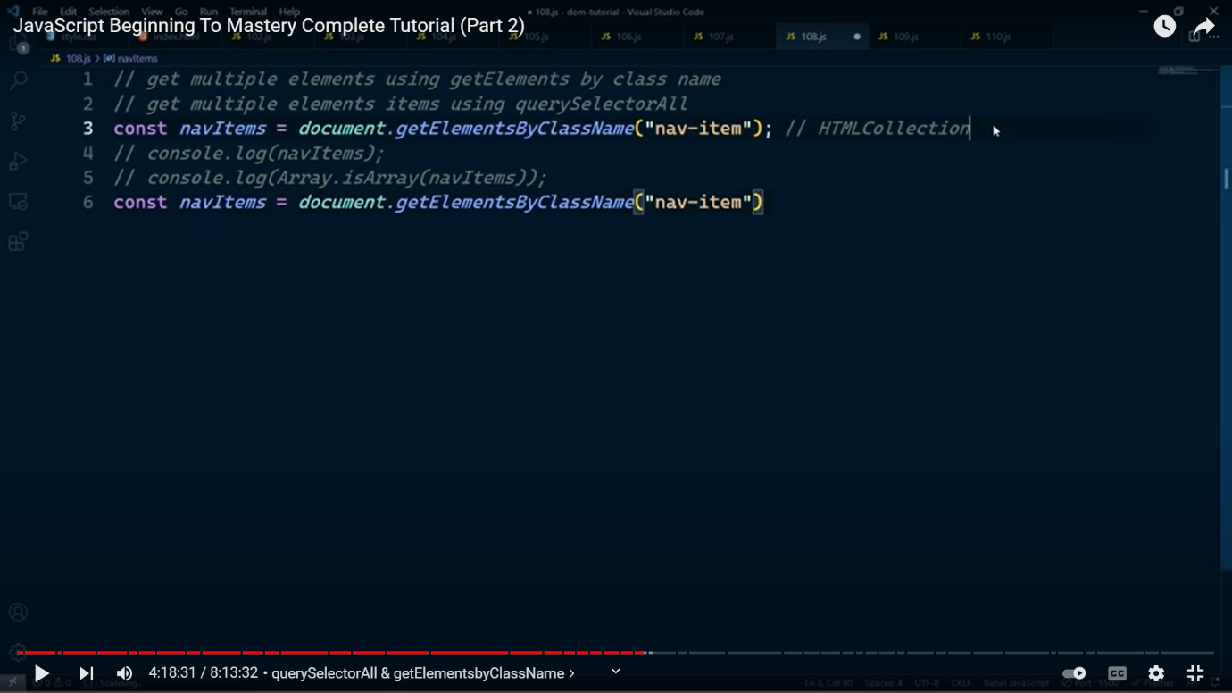

8. document.getElementbyTag()

1 . Change the text

*const* heading=document.querySelector("#heading");

heading.textContent="This is somthing else";

Hidden text VS inner text

note : text content will going to give me all the text wheter we have remove the text from the dom by

display : none ; or visibility : hidden ;

note hidden text will called as hidden text .

2.changing the style

*const* heading=document.querySelector("#heading");

heading.style.color="yellow";

* use of for loop on multiple element selector :
* *const* header=document.querySelectorAll(".nav-items a");
* console.log(header);
* for(*let* i of header){
* i.style.backgroundColor="green";
* i.style.color="white";
* }

Note : Array like object Mai hum kewal

1 .for loop for (let I=0 ;i<header.length;i++)

2 . for of loop (for (let I of header ))

Use kar sakte hai

Note : for Each or Array ka koi bhi method use nahi karsakte hai .

To use for each or any other method :

We can simply convert them into array.

Const arr=Array.for(header)

* NODE LIST :

When we document.qurySlectorAll() it will give a node list ;

* In node list we can use forEach looping method
* We can also convert node list to Array in order to use its property
* INNER HTML

Escape : \"btn\"

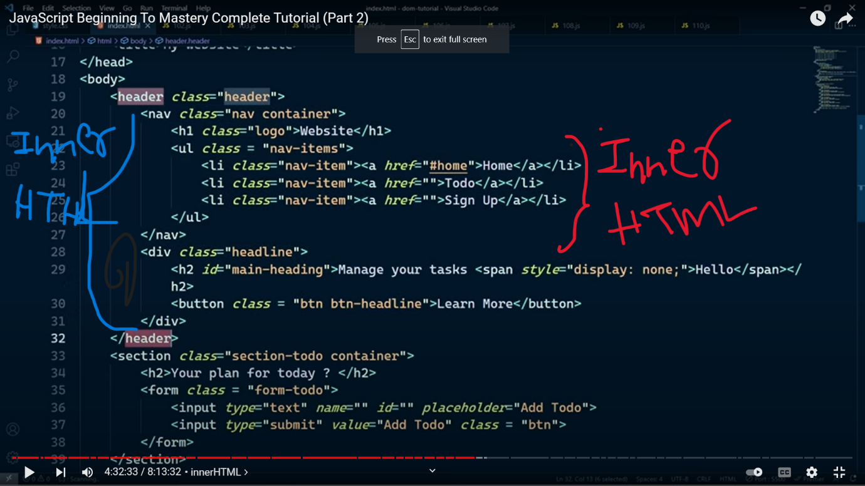

We can access iner html or change inner html :

*const* writeup = document.querySelector(".write-up");

console.log(writeup.innerHTML);

writeup.innerHTML += "<button class=\"btn\">Click Here</button>";

note :

if we want to change in inner html :

a ) if we write

writeup.innerHTML = "<button class=\"btn\">Click Here</button>";

it will over write

b ) to avoid over write or writing multiple innerhtml we use

writeup.innerHTML += "<button class=\"btn\">Click Here</button>";

writeup.innerHTML+="<div>name : <input type=\"Text\"name=\"name\" ></div>"

* TRAVERSING DOM TREE

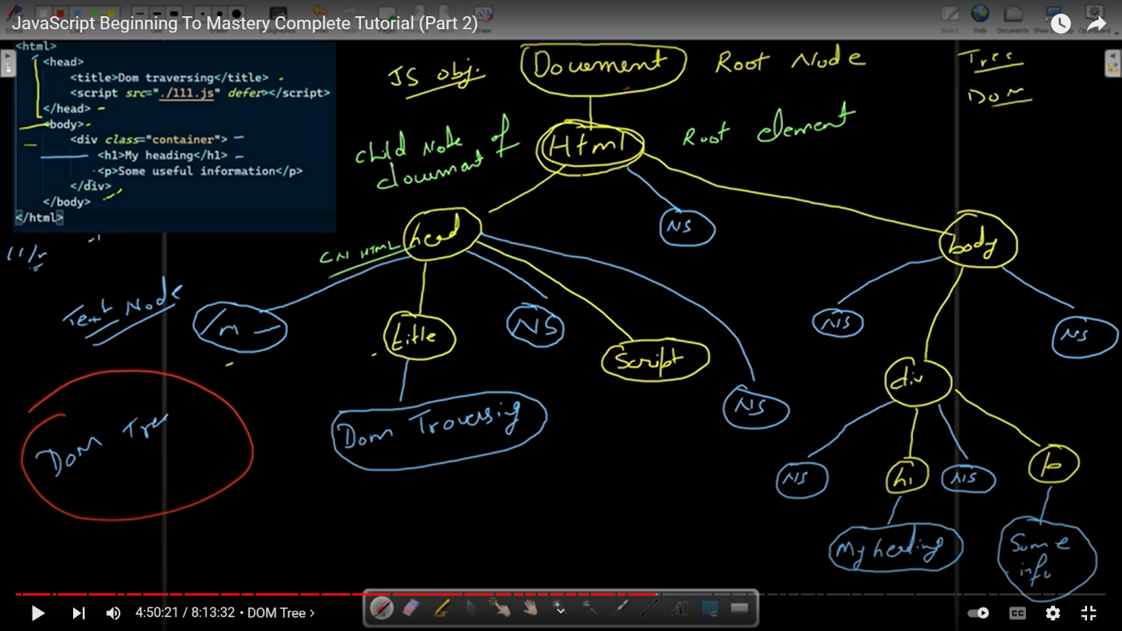

Some important terminology :

1. Docment.rootnode() // give document as shown in upper sc
2. .childnode // give node list of all the child
   1. .firstchild // going to give first child
   2. .lastchild // going to give last child
3. .parentnode // give the parent node
4. .nextsibling // it will going to give next sibling including the text node
5. .previous sibling // going to give previous siblings
6. nextElementSibling // it will going to give next sibling excluding text node
7. .children // it will going to give all child node excluding text node

* .classList

Through this we can find node list containing all the classes

*const* hedderclass=document.querySelector(".form-singnup");

console.log(hedderclass.classList);

method of classList :

1. .classList.add(“ ”) // adding new classes in it
2. .classList.remove(“ ”) // remove existing class
3. .classList.contain(“ “) // going to give true or false whether the class is present in the class or not
4. .classList.toggle(“ “) // agar phele se is name ka class hoga to usko overwrite kar dega agar nahi hai to as new class add kardega

*const* form = document.querySelector(".form-singnup");

console.log(form.classList);

form.classList.add("new-class-1");

form.classList.add("new-class-2");

form.classList.add("new-class-3");

form.classList.remove("new-class-1");

console.log(form.classList.contains("new-class-1"));

console.log(form.classList.contains("new-class-2"));

form.classList.toggle("new-class-1");

console.log(form.classList);

* When to use or not use .inerHTML

When to use : we always try to use .inerhtml when we have over write or completely change the inner html .

When to not use : do try to use add another element .

Inseted of using .inner html we can use document.createElement

The append where ever we want to .

Document.createElement(“ “ ) :

Method :

1. .append(what ever we want to write here )
2. Preappend( what ever we want to write here)
3. .remove(empty) // it will going to remove whatever we have slected before remove
4. . before(what ever we want to write here ) // it will going to add element before the mention id or class not inside the class or id which you have mentioned like .apend() or .prepend()
5. .after( write what ever you want to add ) // it will going to add element after the mentioned class or id or any other slector

Code :

*const* heading = document.createElement("h1");

console.log(heading);

*const* header = document.querySelector(".header");

heading.textContent = "I have written all these thing from java script .";

header.append(heading);

*const* para=document.createElement("p");

console.log(para);

para.textContent="erjioerjoerjrj ewrriopwererwiopeiop wererjiopeiopr" ;

header.prepend(para);

header.remove();

clone :

note jo element hum banayege by document.createElement() it will going to append/prepend/before/after once so in order to makes its clone we use clone

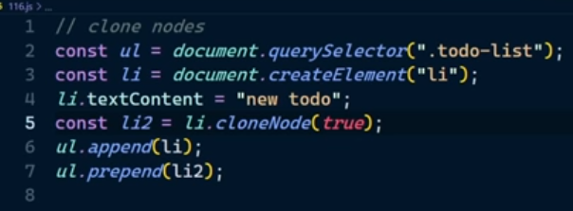

Static list and live list :

Staic list : it is like primitive data types agar hum naya element add karenge to wo auto update ho ke number in console.log(document.qurryslectorAll() ) main ahi dekaya ga

Live test : it is like primitive data types

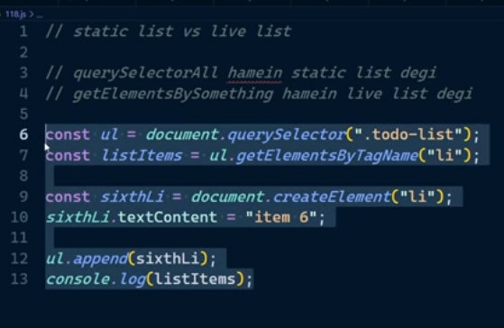

* TO GET ALL BONDING INFORMATION WE NEED TO JUST USE LIKE HEIGHT , WIDTH , MARGIN OR PADDING

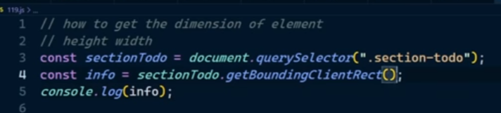

Note to get the all the information about any things :

Const info=document.quryslector(“.header”);

Console.dir(info)

* Intro to events :

1. Click events :

: There are 3 way to add events

A . ) internal adding



We genrally not use this method

B .) By making a function in js file .

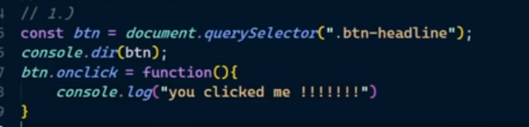

C . ) by using .addEventListener(“Event”,work)

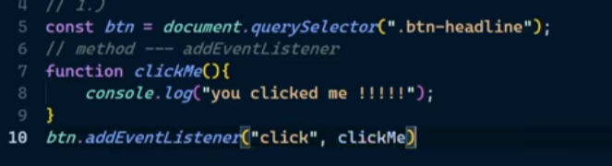

We can also do by making anomnious function in the .addEventListner

Note : try to use this in event adding

EVENT OBJECT :

Note we can not use this with arrow function .

But we can do similar application by using event object

Use of currentTarget , or target

Html code of example :

<!DOCTYPE html>

<html lang="en">

  <head>

    <meta charset="UTF-8" />

    <meta http-equiv="X-UA-Compatible" content="IE=edge" />

    <meta name="viewport" content="width=device-width, initial-scale=1.0" />

    <title>Document</title>

    <script src="pr.js" defer></script>

  </head>

  <body>

    <div class="multiple-button">

      <button>FIRST</button>

      <button>SECOND</button>

      <button>THEIRD</button>

    </div>

  </body>

</html>

Js code for :

*const* button=document.querySelectorAll("button");

console.log(button)

for(*let* btn of button){

    btn.addEventListener("click",(*e*)*=>*console.log(*e*.target));  // e.currentTarget

}